
Headteacher’s Message
As we reach the final day of the autumn term, I would like to take a moment to reflect on my first term as Headteacher. It has been a real privilege to lead the school, and I am incredibly proud of our children and staff. Over the past few months, we have worked together to build resilience across our school community, supporting new learning and encouraging everyone to face challenges with confidence as we look ahead. Thank you to our families for your continued support, and I look forward to all that the spring term will bring.
This term has been full of memorable events and opportunities for our children. Our choir have represented the school brilliantly, visiting venues across the community and sharing their wonderful voices with many. On Monday afternoon, it was lovely to come together with families at St Paul’s Church for the KS2 concert. The beautiful singing and poetry prepared by the children was a joy to experience together.
The Christmas Disco on Tuesday was a fun and festive occasion, giving the children the chance to dance their way into the season and enjoy valuable social time with their friends. On Wednesday, we shared our Christmas Lunch, with staff joining the children to reflect on the term and talk about what they are looking forward to. There were plenty of crackers pulled, crowns worn and jokes shared, creating a warm and cheerful atmosphere. Yesterday, the children enjoyed their class parties, playing games together, and we hope they enjoyed the small gift from school. Today, we ended the term on a high with our Talent Show, and congratulations go to Supernova House, who celebrated their well-deserved win with a house party.
I am delighted to share that our Surrey Young Carers Angel Award has been successfully renewed following its two-year review. This award recognises the care, understanding, and support we provide for our young carers, ensuring they feel safe, valued, and able to thrive at school. A huge thank you goes to our wonderful pastoral team for all they do each day to make this happen and for the consistent care and commitment they show to our young carers.
I would also like to extend a huge thank you to Amazon for their incredibly generous donation for every child in the school, which they received today. We were truly blown away by the time and care that went into creating these wonderful care packages, which included Christmas activities, warm accessories and a heated comfort toy. We are sure these will be warmly welcomed by our community and enjoyed by every child. We are delighted to have been able to secure this donation for our Darley Dene families and grateful to Amazon for their support.
Thank you once again for your continued support throughout the term. I wish you all a happy, restful and joyful Christmas, and I look forward to welcoming everyone back on January 5th in the spring term.
Choir - The choir has been out and about this week spreading holiday cheer to the community. We have visited local care homes and senior drop-in centres to sing, deliver Christmas cards, and bring holiday greetings to the seniors. We have really enjoyed our time making holiday memories!
Delight - Year 4 have finished their Rainforest Retreat from Delight! We have had an amazing term immersing ourselves in the patterns and textures of the rainforest to create a display including fabulous foliage, beautiful birds, and plenty of creative creepy crawlies. We were able to have an open classroom on Wednesday afternoon to show our families the artwork that we have produced and then on Thursday we hosted Year 2 & 3! We have really enjoyed our time completing our delight activities this term and we are really thankful to Delight for providing us with this opportunity.




Our
Facebook
Page

LAN Centre
News

Nursery
News

Reception
News

Year 1
News

Year 2
News

Year 3
News

Year 4
News

Year 5
News

Year 6
News

Time to talk
Understanding what makes children and young people feel happy, safe, and loved helps us support their wellbeing and build resilience when challenges arise. This half term, we will be focusing on Questions to Understand Their Positive Feelings, sharing weekly prompts to help guide meaningful conversations at home and nurture those positive emotions.


How do you feel when you achieve a goal that you’ve been working towards?

Reading
Well done to everyone for working so hard in their reading lessons this term. The children have shown great commitment and enthusiasm, and it has been wonderful to see their progress. Yesterday, I introduced the new reading challenge, and everyone seemed very excited and eager to take part. We hope this enthusiasm continues over the break - happy reading over the holidays!

Maths
➕➖✖️➗
What a jam-packed term we have had in Maths! I have really enjoyed dropping into classes and seeing all the wonderful learning happening across the school. It has been fantastic to see pupils exploring, questioning and building confidence in their mathematical thinking.

Although the holidays are upon us, Maths doesn’t have to stop! There are plenty of simple and enjoyable ways to keep Maths alive over the break - without it feeling like work. By weaving Maths into everyday activities, children can continue to practise key skills while having fun.

➕Go on a number hunt at home or out and about. Children can look for numbers on doors, buses, signs or in shops. Ask them to read the numbers, put them in order, or talk about which is bigger or smaller.
🎄Use baubles, tinsel, or small toys to practise counting, sorting by colour or size, and making simple patterns. Children can also count how many decorations are on the tree or in a room.
🎄Use Christmas activities to explore fractions and time — for example, cutting a cake or pizza into equal parts, or planning a Christmas Day timetable and calculating how long activities last.
⏱️Get children involved in cooking, measuring, reading timetables or planning journeys. They can work out totals, calculate time durations, measure lengths and explore fractions and decimals through everyday activities.

Music
Last Friday marked the close of our survey on Music Lessons at Darley Dene. We had an incredible amount of interest in music lessons with nearly half of respondents indicating that their child would be interested in Piano lessons in the Spring Term. This was closely followed by Vocal, Guitar and Clarinet. We have shared the results of the survey with our partners at Surrey Arts and they are reaching out to instructors in order to arrange lessons. When we have put together a timetable of available lessons and instructors, we will share this with families and provide the opportunity to register for in-school tuition.

KS2 Christmas Concert
Thank you to the families who came to support the KS2 Christmas Concert. When I asked the KS2 children to reflect on this first term as part of assembly this week, quite a few of them spoke about how proud and excited they felt to perform at the church for the community. Specials thanks to the church for accommodating us as they do every year!

Oracy Celebration
All of our children are enjoying the opportunity to earn one of the certificates. Well done to all the children who have already been successful and good luck to everyone else for the coming weeks.
Oracy Champions

Isabella AD
Remi
Dolcie
Thabie
Bahar

Sports Stars
Victoria
Jayleen
Hunter
Chloe
Skylar

Jigsaw
Eslem
John
Tariq
Olivia

Maths
Sia
Noah LA
Noah M
Logan
Charlotte
Matt W

Writing
Zayne
Jacob
Elfida
Hallie
Roni
Daisy-May
Lena

Gold Leaves
Congratulations to the children who earned a Gold Leaf this week. This could be for an exemplary piece of work, an over and above gesture of kindness, showing responsibility, perseverance, determination or other positive trait etc.
LAN Centre: LAN Class for an amazing term!
Nursery: Gio
Reception: Tae, Mahadev
Year 1: Deina, CJ
Year 2: Elif, Marya
Year 3: All of Year 3!
Year 4: Year 4 for our hard work on putting together our Art Exhibition!
Year 5: Alan, Elsie-Jean, Daisy
Year 6: Jude, Sudem, Kayden, Hargun, Jake

Timestables Rockstars
Eleen, Paige, Jayden

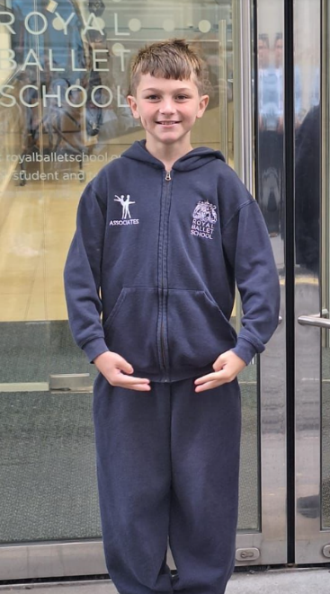
Outside Achievements
Congratulations to Jude in Year 6, who has been awarded a prestigious scholarship to The Royal Ballet School. This is an exceptional achievement and a testament to his dedication, talent, and hard work. We are incredibly proud of him and wish him every success as he continues his training.

Messages from the School Office
Uniform
We want children to be proud of Darley Dene and to take a pride in their appearance whilst wearing our school uniform, encouraging a sense of belonging amongst the children as well as embedding our identity in the wider community.
Please ensure that your child’s uniform including Coats, Jackets and PE Kits as well as water bottles are named.

Earrings
It is a Trust-wide stipulation that school children must not wear earrings while taking part in PE lessons. Members of staff cannot remove earrings on behalf of children so a child must be able to remove their earrings independently or alternatively the earrings are removed before they come to school. Children with newly pierced ears are included in these guidelines and so are also required to remove their earrings; the duration of the lesson is not long enough to allow piercings to close over. Additionally, we are not able to allow children to take part in lessons with plasters covering earrings so it is imperative that children learn to remove/insert earrings themselves.

Pupil Premium/FSM

Have your circumstances changed? You may qualify for your child to have free school meals and other benefits under the Pupil Premium/FSM scheme from Surrey County Council. Scan the QR code to check.

Breakfast and After School Club
A reminder to parents that spaces in both these clubs are limited. Please ensure you book within 48 hours prior to the days needed to secure your child’s space. If you need help booking, please call the office.

Entrance to School
Entrance to the school should be via the main school gates only between 08.30am - 08.50am. If you need to speak to the office staff, parents should go via the internal door to the office from the playground. The main office entrance is for the use of Breakfast Club only before 08:30am.

Water bottles
Water only is allowed in children’s water bottles. No juice or sugary drinks are allowed in school. Please also name your child’s water bottle.

Lunch Boxes
Darley Dene is a nut free school. Please DO NOT send your child to school with chocolate spread Sandwiches, chocolate crepes for lunch as it is not possible to distinguish between Nutella and a nut free chocolate spread. If your child has a chocolate spread sandwich or a chocolate crepe we will call home to request that an alternative be brought in. Thank you for your co-operation.

School Meals

Autumn term menu available click here
Please continue to pay for lunches through your ScoPay account.
Nursery £2.49
KS2 £2.80

Medication
If your child has been prescribed with medication which needs to be administered during the school day, please ensure that you complete a Pupil Medication Request form which can be found on the school’s website or from the school office. Without the completed form staff will not be able to administer any medication.
Attendance & Fixed Penalty Notices  Amount Payable for a Penalty Notice and Consequences for repeat unauthorised absences  1. If you have not incurred a penalty notice relating to this child/children in a rolling 3 year period since 19 August 2024, then the penalty notice will be charged at the rate of £160.00, per parent/carer per child, if paid within 28  days. This will be reduced to £80.00 if paid within 21 days of receipt of thenotice. Failure to pay the Penalty Notice will result in Surrey County Council considering legal proceedings against you in the Magistrates Court.  2. If you have incurred a penalty notice relating to this child/children since 19 August 2024, the rolling 3 year period will be activated from the date of the first penalty notice and the second penalty notice will be charged at the flat rate of £160.00, per parent/carer per child, if paid within 28 days. There will be no reduction for payment within 21 days. Failure to pay the Penalty Notice will result in Surrey County Council considering legal proceedings against you  in the Magistrates Court.  3. If you have incurred 2 penalty notices relating to this child/children in the rolling 3 year period since the first penalty notice was issued, then you will NOT receive a third penalty notice – Surrey County Council will have no option but to consider a prosecution, per parent/carer per child, in the Magistrates Court under s 444 Education Act 1996.  Surrey County Council is not responsible for authorising pupil absence and therefore cannot withdraw any Penalty Notice requests without the written permission of the Headteacher.  Attendance & Punctuality Policy 2024 | 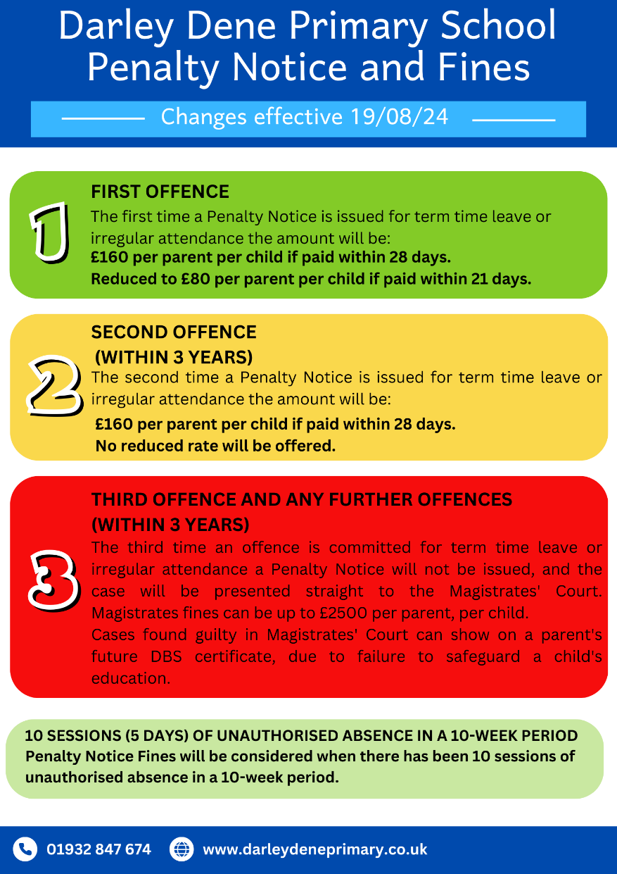

Vacancies
Darley Dene Primary School is recruiting: We are seeking to appoint a highly enthusiastic, proactive, flexible and reliable individual for the role of Teaching Assistant on a fixed term contract to cover a maternity leave. This is an opportunity for individuals who are patient and emotionally resilient to join our friendly, inclusive and inspirational team of teaching and support staff.
If you actively enjoy working with children in a stimulating and creative environment, have experience ideally within the education sector and are professional in your approach with a desire to make a lasting personal contribution to our children’s lives, we want to hear from you. For more information please visit: Teaching Assistant

The Echelford Primary School is recruiting: We are recruiting a Wraparound Care Manager (24.75 hours per week, 7:00 am 8:45 am and 3:00 pm - 6:00 pm, Monday to Friday, with an additional 1 hour per week for admin tasks during term time (38 weeks per year). We are offering a wonderful opportunity to become an integral part of our exceptional community of children and adults. We are looking to appoint someone who wants to create a provision that is stimulating, safe, caring and creative. The right candidate will be organised and able to lead and work as part of a team and use their own initiative. For more information on these roles please see: Wraparound Care Manager

The Echelford Primary School is recruiting: Contract (12 hours per week, 3pm – 6pm three afternoons per week and 7.30am - 8.30am three mornings per week, term time only (38 weeks per year). Flexibility around these hours may be considered. We are offering a wonderful opportunity to become an integral part of our exceptional community of children and adults. We are looking to appoint someone who wants to create a provision that is stimulating, safe, caring and creative. The right candidate will be organised and able to lead and work as part of a team and use their own initiative. For more information on these roles please see: Wraparound Care Manager

Walton Oak Primary School is recruiting: We are recruiting an Early Years Teaching Assistant (32.5 hours per week, 8.30am to 3.30pm), term time only (38 weeks per year), Monday to Friday. We are looking for somebody who is not afraid to make mud pies and, if asked to be a zoo keeper, can jump into role and immerse themselves in the children’s play. We are looking to appoint somebody who can be flexible and support learning in a creative way.
For further information please visit: EYFS Teaching Assistant

Walton Oak Primary School is recruiting: We are recruiting a Part Time Early Years Teaching Assistant (20 hours per week, 11.30am to 3.30pm), term time only (38 weeks per year), Monday to Friday. This is a fixed term position to the 31st August 2026. We are looking to appoint somebody who can be flexible and support learning in a creative way, who is not afraid to immerse themselves in the children’s play. The successful candidate will join a hard working and dedicated team of teachers and support staff. For further information please visit EYFS Teaching Assistant

Upcoming Diary Dates
Term Dates 2025 - 2026
Spring Term 2026
Mon 5th Jan - Children return to school
Mon 5th Jan - Year 6 WWII Workshop
Tues 6th Jan - Year 5 Viking Workshop
Wed 7th Jan - Little City EYFS & LAN
Wed 14th Jan - English Hub Visit
Tues 20th Jan - Homework Help Y1-Y6 Parent Workshop
Tues 20th Jan - Year 5 trip to SKY Academy
Wed 21st Jan - Resilience Workshop for parents
Fri 30th Jan - Year 4 Bikeability
Fri 30th Jan - Whole School Coffee Morning
Mon 2nd Feb - 6th Feb - Maths Enterprise Week
Mon 2nd Feb - Year 1 trip to The Look Out Centre
Tues 3rd Feb - Maths Early Number YR-Y1 Parent Worshop
Thurs 5th Feb - Magma Maths Y2-Y6 Parent Workshop
Fri 6th Feb - NSPCC Number Day
Fri 6th Feb - Year 4 cake & ice lolly sale
Mon 9th Feb - 13th Feb - Children’s Mental Health week
Mon 9th Feb - Internet Safety Parent Workshop
Mon 9th Feb - Family Consultations 4.30pm - 7.00pm
Tues 10th Feb - Year 2 St Paul's Cathedral Trip
Wed 11th Feb - Family Consultations 3.30 - 6.00pm
Mon 16th Feb - Fri 20th Feb - HALF TERM
Mon 23rd Feb - Children return to school
Mon 23rd - Wed 25th Mar - Y4-Y5 Bowles Trip
Tues 24th Feb - SATS Information meeting - Year 6
Mon 2nd - Fri 6th Mar - Book Week
Mon 2nd Mar - Surrey Singing Music Festival 2-7pm
Wed 4th March - Year 3 Forces & Magnet Worshop
Thurs 5th Mar - Bedtime Stories - Parents and Children 5:30pm-6:45pm
Thurs 5th Mar - Year 2 Florence Nightingale Workshop
Mon 9th Mar - Stay, Play and Learn - Nursery 2pm - 3pm
Tues 10th Mar - Stay, Play and Learn - Reception & LAN 2pm - 3pm
Wed 11th Mar - Year 5 Class Assembly
Wed 11th Mar - Stay, Play and Learn - Reception 2pm - 3pm
Thurs 12th Mar - Year 4 Roman Villa Visit
Thurs 12th Mar - Young Carers Day
Thurs 12th Mar - Stay, Play and Learn - Nursery 2pm - 3pm
Fri 13th Mar - Comic Relief Day
Fri 13th Mar - Year 3 cake & ice lolly sale
16th Mar - 20th Mar - Year 6 Mock SATs
Tues 17th Mar - Year 4 Class Asembly
Thurs 19th Mar - LAN trip to Bocketts Farm
Fri 20th - Mar - Resilience Workshop for parents
Mon 23rd -27th Mar - National School Football Week
Tues 24th Mar - Year 6 Class Assembly
Fri 27th Mar - End of term 1:00pm
Tues 31st Mar - Multiplication Tables Check - Year 4 - parent talk

Summer Term 2026
Mon 13th Apr - Children return to school
Fri 17th Apr - Year 2 cake & ice lolly sale
Mon 25th May - Fri 29th May - HALF TERM
Mon 1st June - Children return to school
Fri 12th June - Year 1 cake & ice lolly sale
Mon 15th June - Stay, Play and Learn - Nursery 2pm - 3pm
Tues 16th June - Stay, Play and Learn - Reception & LAN 2pm - 3pm
Wed 17th June - Stay, Play and Learn - Reception 2pm - 3pm
Thurs 18th June - Stay, Play and Learn - Nursery 2pm - 3pm
Fri 3rd July - Year Reception cake & ice lolly sale
Fri 17th July - End of term 1:00pm
Mon 20th July - INSET DAY
Tues 21st July - INSET DAY 5

Term Dates 2026 - 2027
Autumn Term
Tues 1st Sept - INSET DAY 1
Wed 2nd Sept - INSET DAY 2
Thurs 3rd Sept - Children return to school
Fri 16th Oct - End of term - normal time
Mon 19th Oct - Fri 30th Oct - Half term (two weeks)
Mon 2nd Nov - Children return to school
Fri 18th Dec - End of term 1:00pm

Spring Term 2027
Tues 5th Jan - INSET DAY 3
Wed 6th Jan - Children return to school
Fri 12th Feb - End of term - normal time
Mon 15th Feb - Fri 19th Feb - Half term
Mon 22nd Feb - Children return to school
Thurs 25th Mar - End of term 1:00pm

Summer Term 2027
Mon 12th Apr Children return to school
Fri 28th May - End of term - normal time
Mon 31st May - Fri 4th Jun - Half term
Mon - 7th Jun - Children return to school
Tues 20th Jul - End of term 1:00pm
Wed 21st - INSET DAY 4
Thurs 22nd Jul - INSET DAY 5

Kind regards

Zoe Devonport
Headteacher







